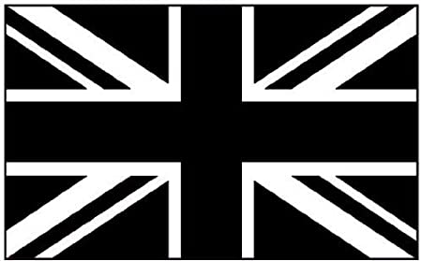
Year 2 – Our United Kingdom
Engage | London Landmark Adventure  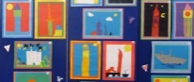  Take the children on a tour of London, using Google maps to guide them around the key landmarks. Has anyone ever visited London before? What did they see? What are the key landmarks? Why are they special?  Add the key images of the landmarks to the class map of the UK. Highlight where on our map London is and show our location in relation to it.  Show the children an example of collage artwork used to depict a key landmark in London. What shapes have been used? Have the correct colours been used? What colours do we think represent London? Why? Children create collage images of places in London using colours associated with the capital. (red, blue etc.)
Express | Window Artwork
Focus Subject | Geography
Why? | We want the children to understand our British values, and to do that we believe they must understand what it means to be British. We want children to have a clear understanding of each country in the United Kingdom: about its history, heritage and the distinguishing features that make each country unique. While we want the children to understand about where they live, we also want to develop their sense of unity with other countries, that they are a global citizen and that they are part of wider, more diverse communities.
Key Knowledge | Geography  - Name the continent, country and county that you live in  - Regional difference between England, Scotland, Wales and Northern Ireland  - e.g. flags, mountain ranges, rivers, capital cities and distinguishing characteristics  Art  - To know what the primary colours are  - To know how secondary colours are made
Express | Window Artwork  ‘Read’ the children the book Window. What different images can the character see through her window? What can we see through our window? How might these images be different if you lived in the different places in the UK?  What key landmarks/symbols/landscape could you include in each picture? Ask children to recap on their learning on each country to recall key symbols and images that they might be able to see through a window. Children use a range of media to create and display their artworks.

Year 2 - Our United Kingdom - Art
Learning Objective | Teaching Input | Outcomes
To understand the difference between primary and secondary colours  To create secondary colours | Recap the primary colours – what are they? What does it mean?  What is a secondary colour?  Show children a range of secondary colours. How can we make this colour? Ask children to discuss and then suggest how we can make that colour.  Model using two primary colours to create a secondary colour before the children begin their independent task. | 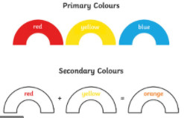  Children experiment by mixing primary colours together to see what secondary colours they produce.
To use primary and secondary colours | Show children the Giants Causeway work alongside a photo of the famous landmark. Explain that we will be learning more about this landmark later in our Geography learning.  Can children work out what the different shapes are representing? What do the circles represent?  Model mixing colours to create a secondary colour and then using the stamp to begin and build the artwork. | 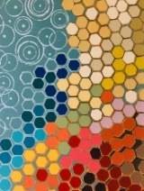  Giant’s Causeway Art  Children use the stamp  to create their own  version of this artwork.  Where have you used  primary colours?  What about secondary colours?
To develop knowledge of a particular style | 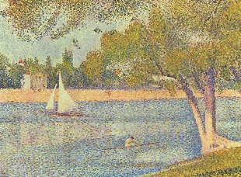  Recap primary and secondary colours, looking at how Seurat blended primary and secondary colours during painting. His philosophy was based on the science of the eye, and that by painting dots closely together, the colours would blend, creating a unique effect. Show  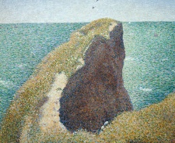  examples of his work, what types of place did  he like to paint? Where are these places?  Discuss the places he painted and ask the  children for other places that could be painted  in this style | 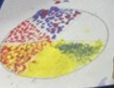  Create a colour wheel using pointillism.  Provide children with different ways of creating the dots so that they can evaluate which they think is the most effective, ready to use in the next session.
To create art in a particular style | 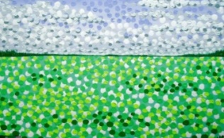  Show children a range of photos of  landmarks and landscapes of the UK.  Where are these places? Has anyone  visited them? Why might they be  effective places to create a painting  of?  Model setting out the key features  of the picture and then using pointillism to add colour. | (Over 2 lessons)  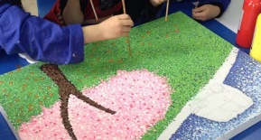  Children choose a landmark to draw/outline. They then use pointillism to  add colour to  their picture.

Y2 The UK - Geography
Learning Objective | Teaching Input | Outcomes
To understand that the UK is made up of four countries | Look at maps of the UK – can we identify the countries within it?  Has anyone visited any of the other countries?  Discuss the map and explain that each country is shown in a different colour. Read the names of the capital cities and explain that these are very important places with lots of buildings.  Where do you think we live?  What seas surround us?  (Create large map for display that can be added to over time)  Look at the Union Jack – what is it made up from?  Look at the creation of the Union Jack and how union means ‘joined together’ | 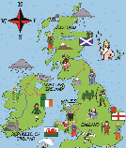  Children create Union Jack flags. These could be built up in a layered way to show how the different flags come together to make the Union Jack  As a class, build and discuss the large UK map for display. Key symbols will be added to these at a later date.
To understand which county we live in | Locate the school on a map. What county are we located in?  Show children a county map of the UK. Does anyone know whereabouts in the UK we are on the map? What county does that mean we are in?  Share some key images of Norfolk on the board. Ask them what they think the images represent. Discuss the different areas and ask if they were aware of these things.  What images represent our county?  What is it famous for? | Children write a short explanation of the county they live in and draw images which represent it.  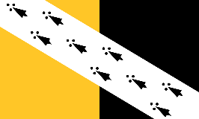  Have a go at making the flag of Norfolk.
To understand the county which we live in  (x 2 lessons) | What is it like to live in Thetford? What key features do we have in our town? Does everyone have the same experience of living in Thetford? How could people’s experiences be different?  Show the children a range of photos (rivers, statues etc.)  Where do they think these places are? Explain that they are all Thetford, but that all places have different views and areas (urban/rural) What view of Thetford would you like to have from your window? Why? | 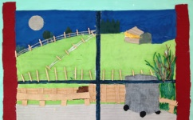  Imagine you lived on these two different streets in Thetford.  How would/could your view be different?  Children create art showing what might be seen out of different windows in Thetford.
To recognise Scotland as one of the countries of the UK | Remind the children about the different countries that make up the UK. Where is Scotland? What do we already know about Scotland?  Share some key images of Scotland and see what the children know already. Show children the photo of the Loch Ness monster and tell them the story (Twinkl). Why do they think this story is still famous today? Show children the Loch Ness fact or fiction cards.  Imagine you have spotted the monster. How would you feel? | 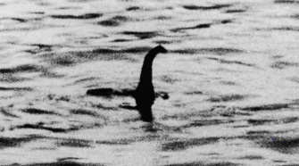  Children write a newspaper report about a sighting of the Loch Ness monster.
To recognise Scotland as one of the countries of the UK | Recap the images of Scotland from yesterday and show the kilt. Explain that these were/are worn by different clans in Scotland as a symbol of honour. Each clan has an assigned tartan. Show examples on the board.  Explain that a kilt is traditionally worn by bagpipe players. Show a video of the bagpipes being played and continue to play music during the tartan task. | 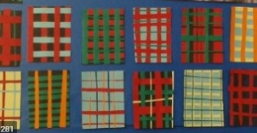  Create tartan using paper weaving  to achieve the pattern.
To recognise Wales as one of the countries of the UK | Recap the countries again. Where is Wales. Say Well done when a child gets in right – but in Welsh. Explain that the Welsh have their own language which is spoken and can also be seen on things such as road signs in their country. Teach some greetings and let the children have a go.  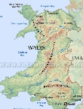  Share photos of the countryside in Wales. How is it different from Thetford? What can you see a lot of?  Share the Mountains of Wales PowerPoint so children can see the full range that can be found | Children create maps of Wales but only show the mountain ranges. Ask the children about the different symbols that we could use as part of the key.
To recognise Wales as one of the countries of the UK | Sit the children down in front of the whiteboard and explain that today we are going to be going on a train up Snowdonia!  Recap where Snowdonia is and what it has around it. Why is it a popular place for tourists? Who might want to visit?  Play the children a first-person view video of a train ride up Snowdonia. What did we see? What do you think the train felt like? What view did we have at the top? How can we use this to describe Wales? | Children create a persuasive advert to encourage tourists to take the train ride up Snowdonia.  Encourage them to describe the views of Wales they had from the top.  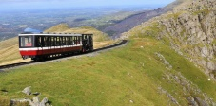
To recognise Northern Island as one of the countries of the UK | Show children a wide range of symbols which reflect Northern Ireland traditionally.  What impressions do you get of this country? What is it known for? Do you think Irish people are happy about this?  Show some photographs of landscape/sport/art/architecture in NI. What else could it be known for? Which positive symbols could be used to describe this country? | Add NI to UK map and choose symbols to add from today’s learning.  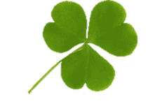  Children explain which symbols they have chosen to add and why
To recognise Northern Island as one of the countries of the UK | Remind children of their learning on the Giants Causeway in Art. Why is It famous?  Explain to the children that there are 2 stories which explain how the Giants causeway came to be. Explain that they are going to have to choose which one is true, or which one they prefer, to retell to their friends.  Why do you think it is called the Giants Causeway?  Why was this story invented? | 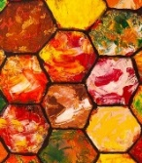  Choose their favourite story to explain how the Giants Causeway was formed. Children storybaord/story map their choice.  Giants Causeway Art (links to art) with a short explanation of the two ways in which it was formed.

Further Ideas
PE - Scottish Dance
PSHE -Unity and togetherness

