Geography
Y2 What makes us special?

Learning Objective | Teaching and Learning | Outcome/s
Engage! | 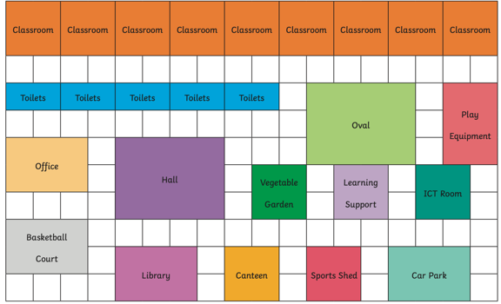  School Treasure Hunt!  Give children the map similar to the one seen here ------- > What places can you recognise? Which places are bigger than others? How do you know?  Explain that around the school there are hidden clues for them to find. They must use the map to find the clues and work together to solve the clues back in the classroom (clues could be to what the hidden object is etc)  Children then work on creating their own maps of the school in this style.
To examine aerial photographs | 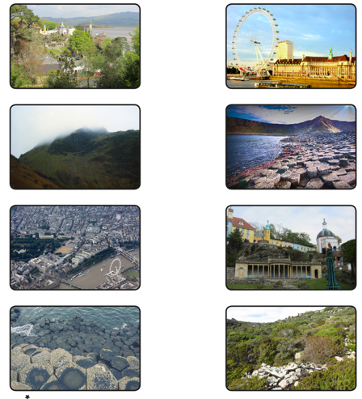  Show children a range of aerial photographs from famous places around the world. What places do you think you can see?  Show a mixture of ground level and aerial photos (see attached resource) --------------------- >  Match ground level photos to the aerial photos – can they recognise any places they have already learnt about this year? (e.g. Giants Causeway)  What are the main differences between the ground level and aerial photos? What changes? When might it be useful to use each of these? | 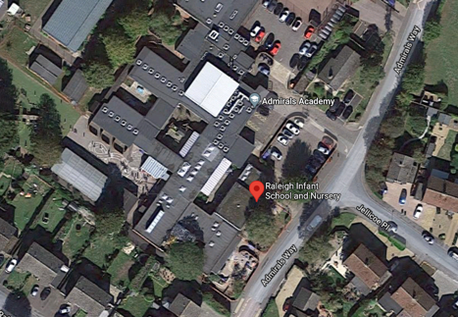  Show children aerial photographs (could be images snipped from Google Earth) of the school within the local area. What can they identify? Where is our school? What surrounds it?  Children annotate the photo to identify buildings, playgrounds, fields, entrances, boundaries, vegetation, and neighbouring land use.
To use the four points of the compass | Show children a picture of a compass with 4 points. When might we need to use a compass? Why are they useful? How do they work?  Show: https://www.bbc.co.uk/bitesize/topics/zrvbkqt/articles/zfb6pbk and as a class create your own model compass. (Children could have a go at this in groups later in the lesson with an adult)  As well as north, what other points are there on the compass? Show the PowerPoint (attached) and talk through the key learning points.  Challenge: does anyone know the other points on the compass? If I tell you that this point is north-east, can you work out the other points? | 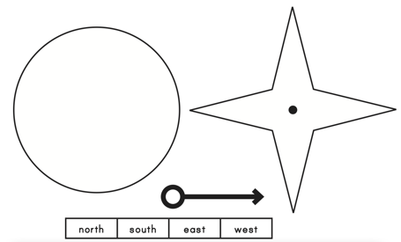  Make a compass  Children create their own paper compass. Will this work in the same way to the needle one? Why? What would we need to use alongside ours to help with directions?
To use the four points of the compass | 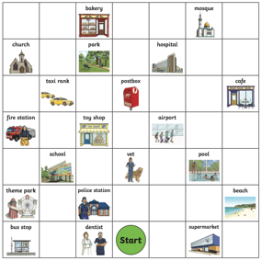  Show children the map at Map  Model using the directions to get to the different places.  Children then work in pairs to use their points of the compass to follow their directions to reach the different destinations.  Explain that now, they are going to use their compass directions to navigate around school, on a letter treasure hunt!  Show children a similar grid, but with a map of the school on.  Explain to the children that they are going to start at different places and then use the directions to find the next clue.  e.g. 10 steps North of the dinner hall is ______ | Letter Treasure Hunt  Children use a grid like the one used at the start of the lesson t navigate around the school/playground/outdoor space. At each point there will be a letter hidden in an envelope. They must collect each of the letters to spell out a word.  e.g. RALEIGH
Trip  To collect and organise simple data | Land use around school – trip  Remind children of our learning using the aerial photographs: what could we identify around school? Recap.  Explain that today, we are going to be geographers, and take a trip out into the local area, to take a closer look at what land is being used for outside of school.  Before the trip/walk, children could set up tally charts for streets/houses/fields/shops etc in an allocated area. Alternatively, you could conduct a traffic survey to encourage less drivers around the school, to keep our school safe and special.  Explain to the children that geographers need facts and data to make their decisions, so it is important that they are accurate with their data.  When back in school, the children could create bar charts or pictograms about what they have learnt.
To use symbols, colour codes and keys on maps | 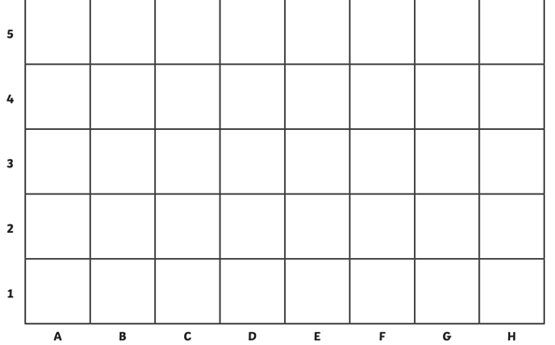  What did we learn from our fieldwork? What is most land used for around our school? Is there a lot of traffic? Why is this? As well as houses, what else can we find around our school? Were there many trees?  Model adding the children’s ideas to a basic map – why might it be useful to use a grid like the one I am using? Encourage children to think about size and directions and the user.  Model creating symbols instead of detailed drawings. Why is this important in a map? What will need to include to help people read our map? Model using a key.  Is it sensible to draw each individual house? What about all of the roads? Model using coloured blocks to depict areas of housing//fields etc, rather than drawing lots of individual symbols. | Create a map of the land use around school – with key  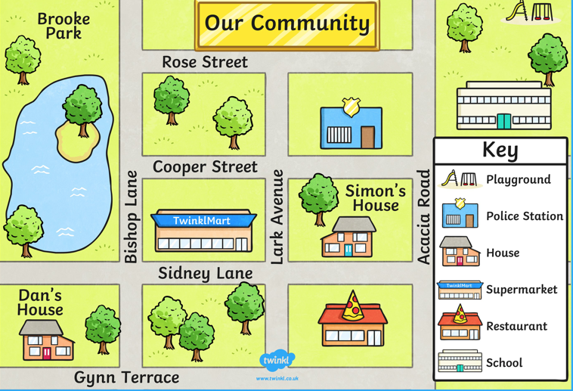
Express  To create simple maps | 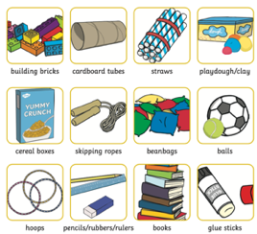  Explain to the children that we are now going to bring together all of our learning to create maps of our local area. But these aren’t ordinary maps – they are messy maps!  Show children the materials they have available to them. How could they use these to represent the houses, the trees, the roads, the school?  How can they make sure that their map is accurate? What will definitely need to be included? | Messy maps  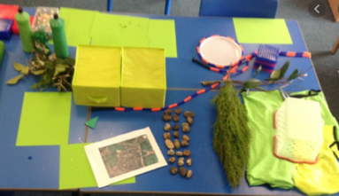  Children work in teams to create messy maps of the school and local area, using a range of recycled and natural materials
Art
Learning  Objective | Teaching and Learning | Outcome/s
To discuss first impressions of art | Show children a range of famous portraits:  - What is a portrait?  - Who are they?  - What are they wearing? What does this tell us about them?  - How are they feeling? How do you know?  - Hand out a portrait to each group and ask them to discuss their thoughts on these portraits before feeding their ideas back to the rest of the class. | 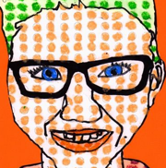  Children recreate two of their chosen portraits and answer the questions:  - Who is the portrait of?  - What colours have been used?  - What do you like about the portrait?  - How would you describe the portrait?
To describe the difference between a portrait and self portrait | https://www.bbc.co.uk/teach/class-clips-video/how-to-draw-a-portrait/zk28qp3  In the last session, we looked at a lot of portraits. What did we learn that a portrait was? What do you think a self-portrait is? Who can create a self-portrait? Can anyone create a self-portrait of you? No -only you can! Today we are going to experiment with a range of materials to create a self portrait. What will we need? A mirror! Model using the mirror to look at the key details on your own face and using the different materials to depict these. | 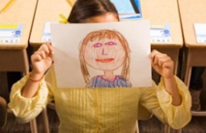  Children experiment with different materials to create their own self portrait using a mirror  - Charcoal  - Paint  - Card  - Pastels
To use different types of line | 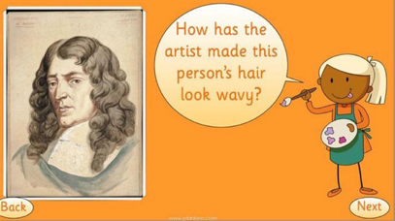  Look at some examples of portrait art. Recap what was learnt in the previous sessions on portraits. Is it a self  portrait? How do you know?  Look at the details of the piece – how has the artist made the hair look wavy? What types of line has been  used? What about how they have shown the expression  of the subject? What lines have been used? Why? | 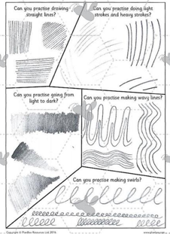  Children experiment making different  types of line:  - wavy  - light/heavy  - light/dark  - straight  - swirls
To use accurate position in portraits | As a class draw the shape of a face.  Where do you think the eyes go? Ask the children to place/draw eyes where they think they should go on the face. (Pin the tail on the donkey style)  Who do we think was the closest?  Draw the lines on the face (see resources for step-by-step instructions) Then model drawing the eyes in the correct position. What surprises you about this?  Repeat the steps for the key features, using the lines to guide position | Children sketch a face with key features in the correct position.  How did the first two lines you drew help you to correctly position the parts of the face?
To create a self portrait | (Prior to lesson take photos of the children, print and cut in half)  Explain to the children that in today’s session we are going to bring together all of our learning to create a self-portrait.  Show the children an example half a photo. What lines can we see? How could we recreate these lines in our own drawing? Model creating the lines, in the correct position, to complete the self-portrait. | 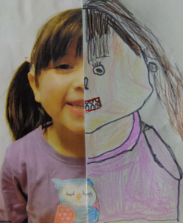  Self portrait – line drawing, bringing together their learning on line and position in the previous sessions.  Higher ability could be challenged to create a complete self portrait without the use of the photo.
To use language of line, shape, colour, texture, and detail to express ideas. | 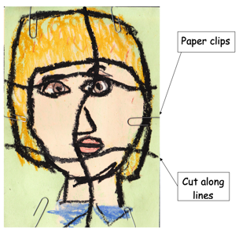  https://www.bbc.co.uk/bitesize/clips/zwyr87h  What have we learnt about portraits? What can you remember about position? Do we think all portrait art needs to be created in this way?  Show children examples of Picasso’s portraiture. What do we notice about his work? What are the key differences between his work and the portrait art we have studied so far this year? Why do you think his work was so popular?  Ask the children to draw a self portrait using pastels.  (see resources for further examples of children’s work) | 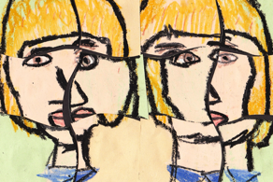  Picasso piece  Then model drawing lines  across and down the page (see example) Try to ensure that while the lines may not be straight, they should be fairly consistent across the class so that the face ‘pieces’ can we swapped and used.  Then there are two options – they could either swap 2 pieces with a partner to create a merged portrait, or they could draw a second self portrait and then mix their own pieces together to create a Picasso style portrait (as in the example)

