History
Y2 How did the Vikings influence Britain?
Learning Objective | Teaching and Learning | Outcome/s
Engage! | 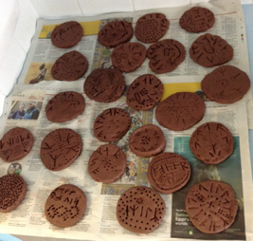  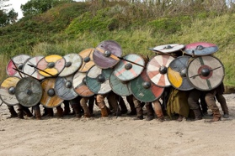  Viking Day!  Take part in a series of activities around a carousel to introduce the Vikings and to immerse the children in their learning. Suggested activities:  - Literacy: Viking sagas https://www.bbc.co.uk/teach/class-clips-video/english-ks2-viking-sagas/zvrmy9q  Watch and retell/create storyboards  - Music: Viking saga songs https://www.bbc.co.uk/teach/school-radio/music-ks2-viking-saga-songs-index/z72w8xs  - History: Viking shields  - History: Viking runes in clay or plasticine
To understand how people and events fit onto a timeline | Introduce our new topic of the Vikings. Look at a timeline of when the time of the Vikings was. Look back at other eras we have learnt about to get a sense of when this was. Explain that we are going to learn about Britain after the Romans left.  https://youtu.be/X0QnGvl3rJo  Show children the timeline dates on the board, can they put them into the correct order | 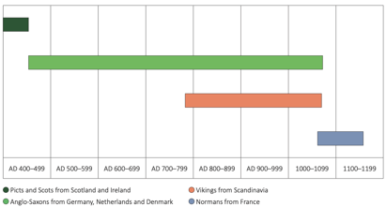  Create a class timeline showing where the Viking fit on the British History timline.  Children could use strips of paper to replicate this in their books and to show the overlap of different periods of time.
Geography
To locate the countries of Northern Europe | Where did the Vikings come from?  Show children Northern Europe on Google Maps. What countries can you see?  Explain that these countries make up Scandinavia  Show https://www.youtube.com/watch?v=zQAhMDM1b4I What did you notice? How did it look different to the UK?  Set up tables as each country in Northern Europe, filled with photos, objects, flags from those places (e.g., Lego, Northern Lights, volcanoes etc) as well as the capital cities  Denmark, Norway, Sweden, Finland, Iceland  Show children a blank map of Northern Europe. Explain that today they are going to move around each country (one per table), locate where it is and add information about what they have learned about each place to the map. Explain that they must choose one key picture to represent each country. | Children complete maps to show the countries of Northern Europe and key features of that place including flags and capital cities.  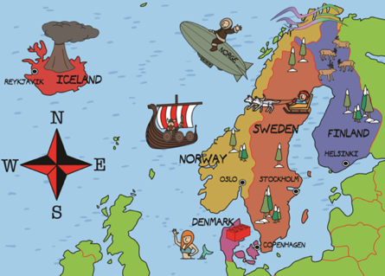  What picture did you choose to represent what you learnt about each place? Why?
To describe and compare the climate of Northern Europe | 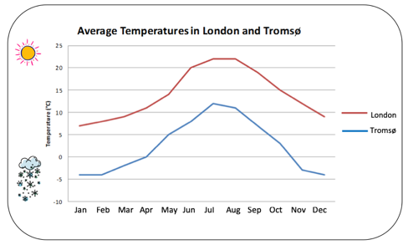  Look at a globe and discuss the location of northern Europe in relation to the North Pole.  Look at the resource showing the climate in the UK compared to the climate in Scandinavia. What can we tell from this graph? °C  Discuss how people have adapted to the cold winters in Finland- sauna, warm homes, winter tyres for cars (studded), snowploughs, grit spreaders, reflector poles that stick out of the snow to show where the edge of the road is, warm clothes etc. | What do the people of Norway need to survive the winter? Pack them a kit of clothing, vehicles and other resources they might need to help them through the winter.  Sort or draw pictures and add to a suitcase, writing a sentence to explain each of your choices.
To describe the human and physical geography of Northern Europe | Now we now what the climate is like in Northern Europe, we now need to think about how that might affects the geography that it has.  Show the words human and physical on the board. What do you think they mean?  What might be the differences? Show children a fjord. Is this a physical feature of Scandinavia or a human feature?  Model sorting the photos/pictures into whether it tells us the physical or human geography.  Which of these will be affected by the climate? Why? | Children sort the picture into human and physical in a table  Which features are similar to the UK?  Which are the most different?  Where would you prefer to live? Why?
To compare Northern Europe to where we live | Recap the learning in the last session – would you want to visit Scandinavia? Why? Children discuss reasons – play Rally table to collate ideas and then feedback to the class. Collate the reasons on the board to use in today’s session.  https://www.youtube.com/watch?v=zQAhMDM1b4I  Use the video as inspiration if needed and ensure that they photos from the last session are on display today.  Explain to the children that today they are going to imagine that they have gone on holiday to Scandinavia and that they are going to write a postcard home about all the things that they have seen.  Remember to include the different physical features that we learnt about in the last session, particularly the ones that we don’t have here in the UK.  Model using the key vocabulary to create concise sentences to showcase the learning. | Children write a postcard home from their travels in Scandinavia.  They must include all of the amazing human and physical geography that they have seen, as well as describing what the weather has been like.
History
To describe Viking exploration | Where did the Vikings come from? Recap learning from Geography sessions  Why did the Vikings want to leave Scandinavia? Think about what we learnt in our Geography lessons, especially our comparison lesson. Why would the Vikings want to leave? Discuss ideas. Explain that these are ‘push’ ideas – reasons to push the Vikings away from where they were settled.  Now lets’ think about the UK. Why did the Vikings choose here to invade? What has the UK got that Scandinavia hasn’t? Explain that these are ‘pull’ reasons.  Show children a reason card on the board (e.g., long, very cold, winters) Is this a push or a pull? Model recording the phrase and picture in the table. | Push or pull?  Children sort the reasons into push or pull in a table.  Which push reason do they think was the most important? Why? Which pull reason do they think was the most important? Why?
To describe Viking exploration | Now we know that the Vikings liked to explore, we now need to learn how they travelled. Look back at the maps of Scandinavia and the UK – how could they get to the UK?  https://www.bbc.co.uk/programmes/p011893p  Show pictures of Viking longships – what do you think made them a good mode of transport? (As the Viking has to travel across the sea they were designed for travelling through water with ease, shallow hull for sailing up shallow water/rivers and for ease of landing on beaches, oak keel for strength, oars were moveable.)  Why do you think there is a dragon for the prow/figurehead? What does it symbolise? | Viking longboats  Children could use information sheets to draw the ships or to have a go at building their own out of card.  What key features will you need to include?  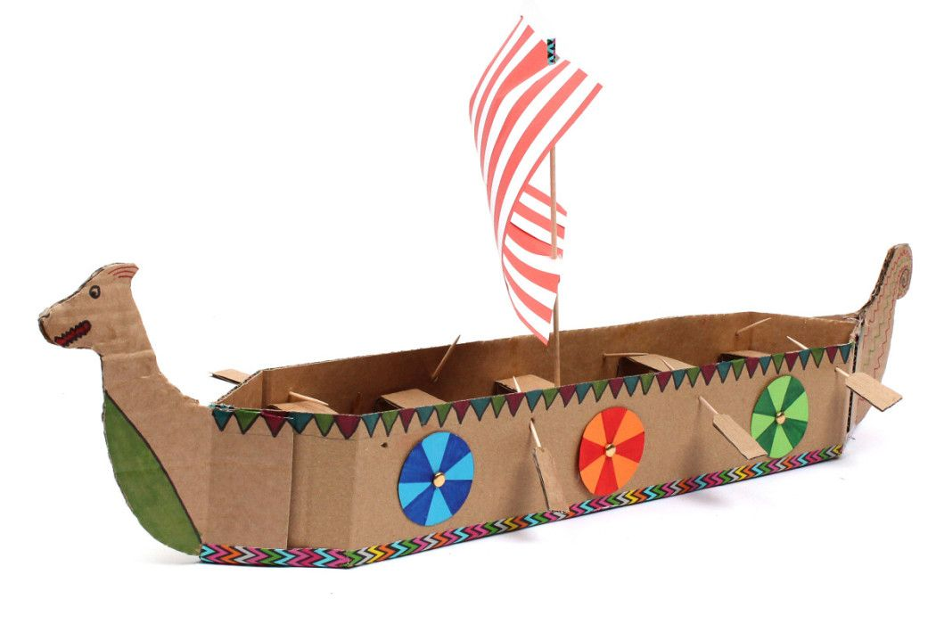
To describe Viking invasion | Explain to the children that the Vikings were successful warriors. Look at pictures of Viking warriors. What do you think made them so successful? Explain that warrior culture was a big part of Viking life. Discuss the weapons, shields and boats used by the Vikings. Why would you fear an invasion?  Imagine you were awaiting an invasion from the Vikings. How would you feel? Play ‘Ride of the Valkyries’ whilst the children think about this. How would the people of Britain felt? | 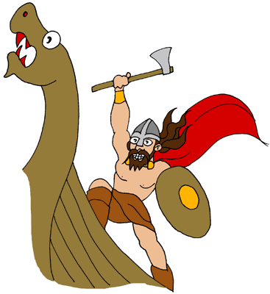  Design a poster to warn of the Viking invasion. Describe the key elements of a Viking warrior – what they would look like, the threat they would pose etc.
To describe the impact of Viking invasions | 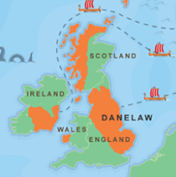  Show children the map of the UK. The Anglo-Saxon lands were to the west and the Viking lands, known as the Danelaw, were roughly to the east.  What do you think life was like? What were the key aspects of Viking life? Show children the PowerPoint on Viking life (attached) and share pictures (attached) What do you thy find most surprising about Viking life?  Explain that the most important city in the Danelaw was the city of York, or ‘Jorvik’ (pronounced 'your-vick'), as the Vikings knew it. Over 10,000 people lived there and it was an important place to trade goods. | Sort children into groups to learn about different aspects of Viking life:  - Clothes and jewellery  - Religion and gods  - Houses and food  - Rhyme and writing  - Art and craft  Children must then feed back to their group what they have learnt to help them answer the questions to the quiz
To describe Viking settlements | 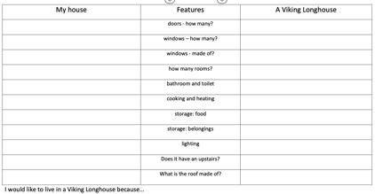  Remind children of their learning in the last session about life in the Danelaw. Explain that today we are going to look bit closer at  the Viking houses.  Show children: https://www.bbc.co.uk/programmes/p0118b7g  (may want to select clips as it is quite long)  What impact did the Vikings have on York?  What were their settlements like?  What else do we now know about the Vikings? What was impressive about their houses? Was there any similarities to our houses today?  Show children the table (attached) to compare their houses to the Viking houses. Provide children with a Viking house diagram (attached) to help them do this. | Children could also build a model of a Viking house, using card and art straws to show the key features.  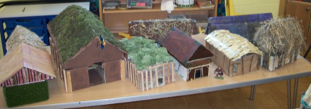
To describe Viking culture | (This might take a couple of sessions)  Remind the children that the Vikings were wide-ranging traders, doing business in many places, from Greenland and North America to Southern Europe and Asia.  Show children the map (attached) and divide the class into 8 groups: each group is a trade centre: Birka, Bulgar, Constantinople, Dublin, Hedeby, Iceland, Jorvik, or Mainz Explain that they are going to be 10th century merchants in these eight centres.  Hand out the cards telling each group who they were and what goods they traded. (These might need condensing down and jazzing up a bit – attached) Hand out the ‘Where to buy goods’ sheet, so they know where to go for the items they need. How might you travel on their trading journeys: by ship, sledge, waggon, horse?  Hand out scrap card and explain to the children that they need to draw their resources onto the card, ready to trade them. Children could also set up their stalls, make name and advertising signs and decide which members of their group were to travel to buy goods and which are to stay and mind the stall. Hand out the same amount of coins to each group to use when trading as well.  Ask the groups to consider what their own centre wanted to buy from other centres: what were they short of, or what could they buy and then sell on? We reminded them that food such as fish was crucial, as were cloth and wool for clothing and bedding. Finally, declare trading open. | At the end of the game ask the children to go back to their groups and assess what they have managed to collect.  Have they got enough of the important resources?  Did they trade successfully?  Show https://www.dkfindout.com/uk/history/vikings/viking-traders/  Look at the picture of the Viking and think about what products would have been made by the Vikings and which would’ve been traded?  Why was trading so important to them?
To order events on a timeline | https://www.bbc.co.uk/bitesize/topics/zxsbcdm/articles/z8q487h (Use this site for sentences and pictures for the children to order)  As a class, recap the key events. Play Rally Table to see which of the events the children can remember and then work as a class to out them into a sequence on the board. (Have the events ready on the board to reveal as the children recall them)  Model using these events to create a storyboard showing the lead up to 1066 | Storyboard of the Anglo-Saxons taking control. Order the events and pictures and create their own storyboard/comic timeline.  Could provide children with pictures to order and add sentences to if needed.  End with Edward dying in 1066. What do you think will happen next?
To ask questions about a period of time | Show children the PowerPoint (attached- aimed at KS3 but easily adaptable)  What makes a good leader? What would you want from your leader today? Why?  Explain that there was more than one contended for the crown when Edward died. Spilt children into groups and give them each a contender and the information about them (attached- aimed at KS3 but easily adaptable). They must present their candidate and persuade us why they think they should be the King. They only have 1 minute though | Who should be King?  Children take part in a group debate – why should they be the King?  Who would you choose? Why? Take part in a class vote and then reveal the real winner. Do they agree??
To use source material to find out about an event | https://www.bbc.co.uk/bitesize/topics/ztyr9j6/articles/z3s9j6f  Watch the comic strip to talk the children through what happened once it was decided that Harold would become King.  http://downloads.bbc.co.uk/schools/primaryhistory/lesson_plans/anglo-saxon/normans_lp_hoh_hastings.pdf  Follow the links on the above link to give the children a section of the tapestry and the corresponding cards each/in groups. Ask the children to look closely at what is happening and discuss what else they can learn from their source.  In groups, present their section to the rest of the class and report their findings. Explain that it is important to listen to each group carefully as we need to work together at the end of the lesson to put the events in the right order. | Bayeux Tapestry  Ask one person from each group to stand at the front with their section of the tapestry.  As a class can we now put the events into the correct  order. Use this to retell the story.  *Correct order is HGDECJIAFB  Children then stick in their section of the tapestry in their books and explain what it shows, They could be challenged to explain what has just happened and what will happen next.
To use source material to find out about an event | 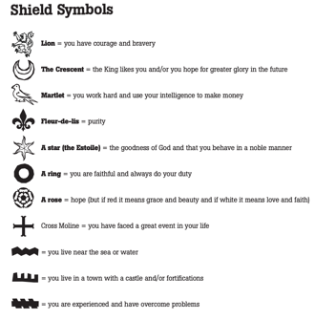  http://downloads.bbc.co.uk/schools/primaryhistory/lesson_plans/anglo-saxon/normans_lp_hoh_hastings.pdf  Remind children of our learning in the last session. what weapons can we see? What are they carrying? Explain that they today they are going to design/make their own shield with a coat of arms.  Show children the list of symbols and colours (on link above) and ask them to think about which values are most important to them and therefore which colours and symbols they will use. | 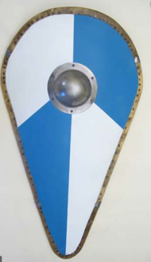  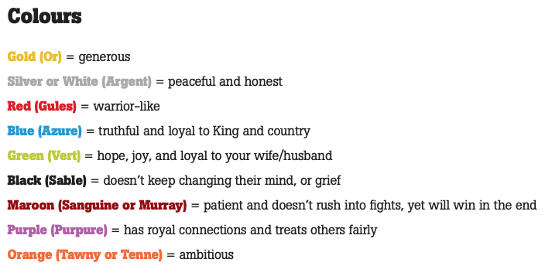  Design a coat of arms for a shield (or children could make a shield)
To describe the impact of a past society on the local settlement or community** | 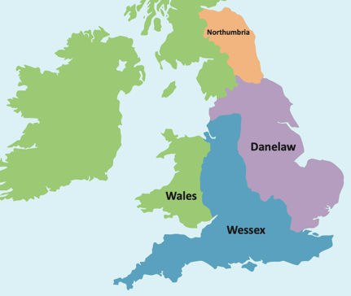  Local area visit/study  Encourage the children to decide if they think Anglo-Saxons or Vikings settled in their local area during the early Middle Ages. Look at the map – were we in the Danelaw or Wessex?  Look at a map of the local area – what place names do you see? Are there any Viking names or Anglo-Saxon names?  (see attached resources for lists of names) Children record the names of places and whether they are Anglo Saxon or Viking in a table.  Use Historic UK website to find an Anglo Saxon or Viking site near you. Either visit or research the area to find out what took place there.

Art
Learning Objective | Teaching and Learning | Outcome/s
To describe the style of a piece of art | (From Knowledge Curriculum document) Show children The Lindisfarne Gospels, c. 715 (British Library, London) and The Book of Kells c. 800 (Trinity College Library, Dublin) Explain that this style of art would have been seen in post Roman Britain and the Lindisfarne Gospel is one of the finest, unique works in this style. Show children’s examples of these pieces and ask them to identify the common features. Explain that today we are going to write the letter of our names in this style. Model step-by-step. Children might want to have a go at the same letter first before attempting their own. | 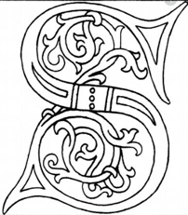  Complete annotations/discussions of the selected pieces of work.  What common features do they find?  Then create letter of their name in the same style. Challenge them to create their own unique detail.
To draw lines and marks from observation | Show children examples of Celtic knots used in artworks, including the ones mentioned in the previous sessions. What do they like about them?  Explain that they were used for decoration but that they are a very important symbol. Let’s have a go at drawing one first:  Drawing activity: https://www.twinkl.co.uk/resource/ks2-celtic-knot-drawing-activity-t-ad-296 | Celtic knots  Example: https://jdaniel4smom.com/2018/02/steam-activity-irish-designs-with-celtic-knots.html  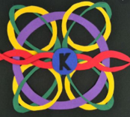  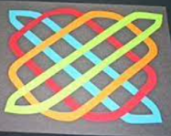
Use malleable materials to create a realistic form | Show children the artefact PowerPoint and discuss what can be learned from looking at artefact. Emphasise – are these Viking artefacts or Anglo-Saxon? What is the difference.  Explain that Sutton Hoo is a royal Anglo-Saxon burial ground near the River Deben, in Suffolk. Historians believe that it was a cemetery for Anglo-Saxon kings who ruled over East Anglia. In one of the barrows, archaeologists found the imprint of a decayed wooden ship. It was 27 metres long, with a burial chamber at the centre filled with a range of precious artefacts.  Explain that in today’s lessons, they are going to choose one of the artefacts to recreate using clay. Model creating the coins and adding the necessary detail. | Sutton Hoo treasure  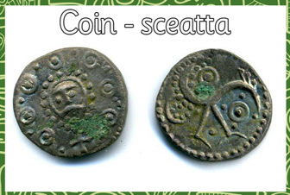  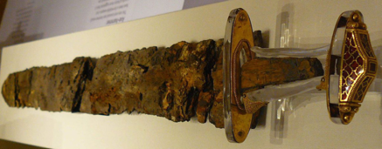  Children choose which artefact they would like to recreate and experiement using the clay to shape and add detail to it.
Use malleable materials to create a realistic form | Use this session to add colour, detail and finish to their Sutton Hoo treasures.  Explain that these treasures are going to be placed in a museum and they need to write an accompanying piece of information or labels to explain what they have made. | Children complete their Sutton Hoo treasures  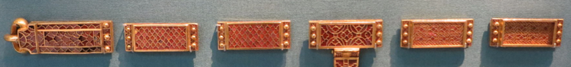
Use a sketchbook to plan and develop simple ideas | Remind children about our learning on the Bayeux tapestry in our History lessons. Why is it important? What does it teach us about?  Remind them that it is an embroidered cloth nearly 70 metres long and 50 centimetres tall, which depicts the events leading up to the Norman conquest of England concerning William, Duke of Normandy.  Show children some images to remind them.  Explain to the children that they are going to recreate a section of the Bayeux Tapestry – you could perhaps choose the voyage across the sea from Normandy for example which would allow you to provide the children with stencils etc. Or each group of children could have a different part to build a class tapestry together.  Explain that although sections are complicated, they need to choose the main symbols and images to create their tapestry.  Model looking at one of the sections and sketching the key images or ideas from the section (knight/shield/boat etc.) | Children sketch the key images from the Bayeux tapestry that they would like to create on their own final piece. This could be human figure, a boat or even just a shield. Remind them to think about what images will be easiest to draw and cut out in the next session, so they won’t be able to choose anything too intricate or detailed or this won’t work in the next stage,  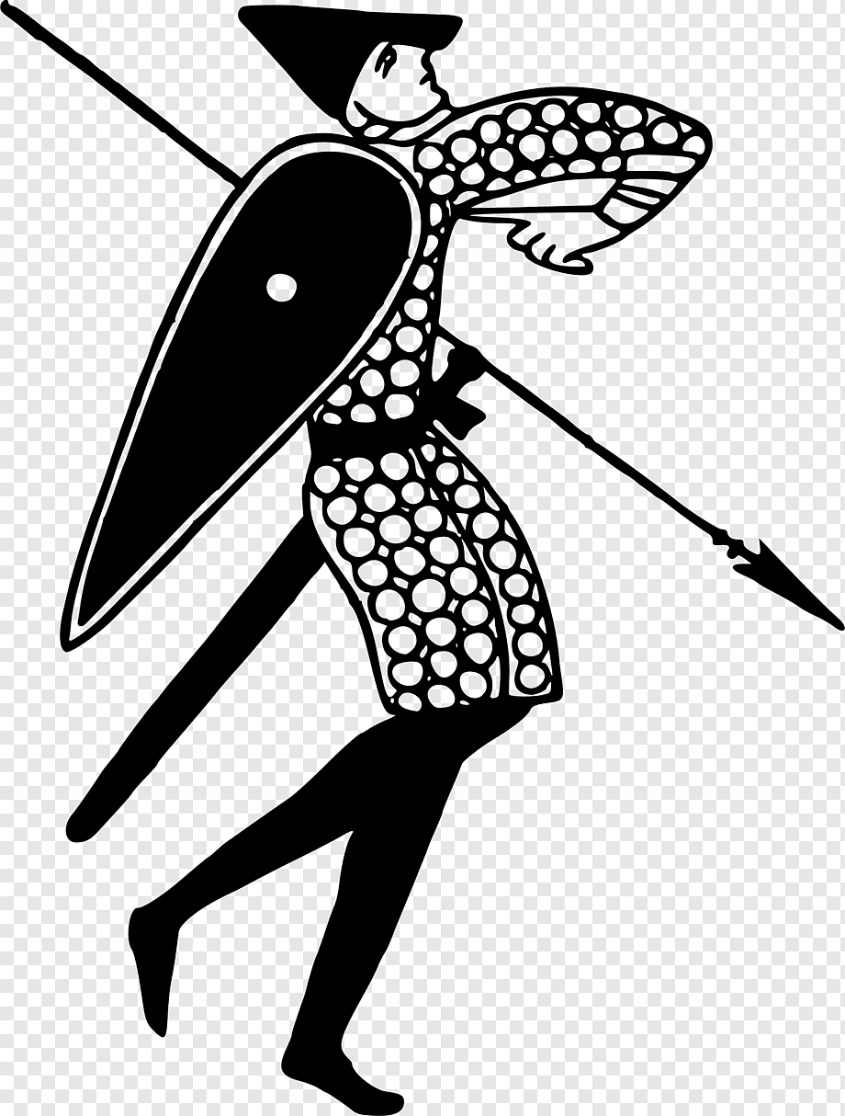  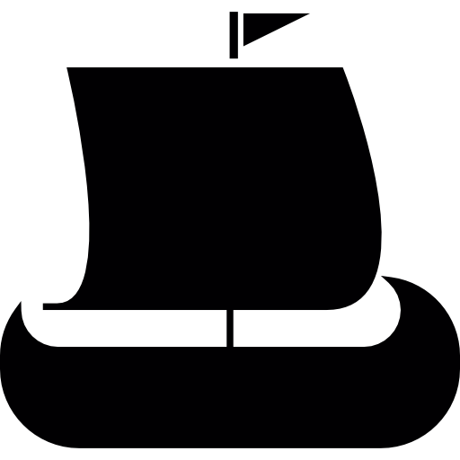
To use different media to consider shape and texture | Explain to the children that they are going to use their ideas to create stencils to be used on their choice of material to create their section of the Bayeux tapestry.  Model drawing a stencil onto card (or could be provided) and using this to around their choice of material.  Model then cutting this out and placing on their ‘tapestry’ – long pieces of card. The children could then place their pieces together to tell the story. | 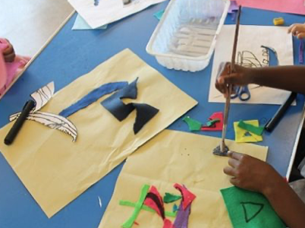  Bayeux tapestry  Children create/use stencils to cut shapes out of other materials to create their tapestry.

Why Did the Vikings Leave Scandinavia?

The word ‘Viking’ comes from the Old Norse word ‘vikingr’ which meant ‘pirate.’ People who went raiding in ships were ‘going viking.’ The people commonly called Vikings were the Norse from Scandinavia (modern Denmark, Norway and Sweden). At home, in Scandinavia, the Norse were mostly farmers, fishermen, crafts people and traders. The Norse people were brilliant at building ships that could sail great distances across stormy seas. They used these ships to travel thousands of miles to trade with countries across the world. It wasn’t long, however, before the Norse traders realised that many of the places they traded with were wealthy and undefended and they began to take what they wanted by force. They began to ‘go viking.’

There are many reasons why so many of the Norse people may have wanted to leave their homes and travel thousands of miles across rough and dangerous seas to loot, plunder and eventually settle and set up homes in foreign countries. One theory is that good farmland was scarce in Scandinavia. Much of the land is either too mountainous, covered in thick forest, or the soil is too sandy. For those Norse families who did have farmland, traditionally only the eldest son would inherit the farm. The younger brothers would have to make their living elsewhere, so they may have chosen the Viking life. Another theory is that wars and power struggles between groups of Norse people would often drive people from their homes. The Vikings were made up of many different groups of people from Scandinavia. These sea-faring warriors not only fought people in Britain and elsewhere in Europe, they fought each other too.

