History
Y1 What does it mean to be British?

Learning Objective | Teaching and Learning | Outcome/s
Engage! | Prime Minister for the Day!  Show a photograph of Boris Johnson on the board. Does anyone know who he is? Does anyone know what his job is? Is his job important? Who to?  Show a picture of Robert Walpole – who do we think he is? Explain that he was the first Prime Minister – all the way back in 1721. How might his job be different to Boris Johnson’s? Do you think all Prime Ministers have the same ideas? What do they all have in common?  Show children the video:  https://www.youtube.com/watch?v=1qYWJarUy7M  What would you do if you were Prime Minister for the day? Why? Ask the children to discuss their ideas in groups and then feedback to the rest of the class. Children must then choose one thing they would do if they were in charge for the day. Ask them to draw a picture and write a short sentence about their idea. Share these ideas with the class and ask them to vote for which idea they like the most, or explain whose idea they like and why.
To understand the importance of the Prime Minister in a parliamentary democracy | Share the story at:  https://assets-learning.parliament.uk/uploads/2019/12/Find-out-about-Parliament-Representing-booklet-.pdf?_ga=2.51609001.1871321009.1620981686-511228872.1607421132  What does democracy mean? Why is it important? Why is it important to listen to everyone’s views?  Think back to our Prime Minister for the Day event – who had the best ideas? Why were they the best ideas? (Practical, realistic, benefitted everyone etc.)  Explain that today we are going to vote for a Class Prime Minister who will help get the views of the class across the teachers and other members of staff. Allow children time to write down/think of a reason why they think they should get the job and then share it with the rest of the class.  Who should you vote for? What reasons should you have for voting? Do you have to vote for your friends? | Take part in a class vote for Class Prime Minister to decide who gets the role  Set up a secret ballot box with a TA and ask children to either write down the name of their vote or tell the adult.  (Ballot box templates can be downloaded from Twinkl)  Count the votes and then reveal the winner. What are their responsiblities now? How can we make sure that they are doing a good job?
To understand where the Prime Minister works | Where does the Prime Minister work? What happens there? Explain that today we are going to take a tour of the Houses of Parliament, to find out what happens there and why it is such an important building: Houses of Parliament 360 tour  Read the children the story at:  Houses of Parliament  What did you learn from our ‘trip’?  Recap some of the new vocab from the glossary  Why is this such an important building? What happens here? Would you like to work here when you are older? Why/why not? | 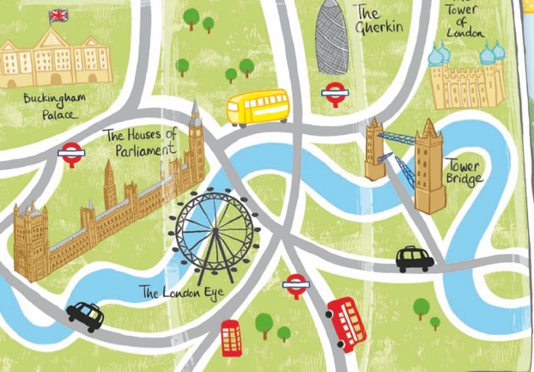  Children create maps of London, showing the Houses of Parliament amongst the other landmarks in London.
To understand the role of the Prime Minister | https://www.youtube.com/watch?v=ex_xxMptomI  https://assets-learning.parliament.uk/uploads/2019/12/Find-out-about-Parliament-Voting-booklet.pdf?_ga=2.155825467.1871321009.1620981686-511228872.1607421132  Why is it important to have Members of Parliament and not just one Prime Minister? Think back to our ideas and class votes. Did everyone agree? Did everyone have the same idea? So then why is it important to discuss/debate these ideas? How does this make it fair?  Show children a selection of questions on the board – they must choose a question that they would like to talk about. e.g. Children shouldn’t have to wear school uniform, Only boys are allowed to play football. Girls should get 10 minutes extra playtime etc. Children vote for the question they would like to discuss. | Once the children have chosen a question to discuss they must choose a side their initial opinions are on (Yes or No)  Set the classroom up in a similar style to the Houses of Parliament and ask the children to sit facing each other. The winner of the class vote from the previous session could wear a badge showing that they are the Prime Minister, and they could begin the discussion. Have the teacher as the Speaker at first, but this could be a child once they get the idea of the role  Children take part in a debate in the style of the Houses of Parliament.  What is our overall opinion? Did your opinion change? Can you see why it is important for the Prime Minister to take part in these debates?
To understand the role of the Prime Minister | What are some of Boris Johnson’s main roles?  Explain that one of his jobs is to decide where money should be spent. What do we think is important to the country – where should your parents money be spent? Ask the children to think of areas and then show areas such as:  Schools Housing Help for other countries NHS Defence Support  Discuss each of these areas as a class – what do they mean? Why are they important?  Explain the children that today they are going to work in mini governments to decide where money should be spent and why | Children work in groups to sort the money into where they think it should be spent and begin to explain why.  Children could be provided with a certain number of coins to sort onto pieces of paper so they can see the physical sharing of the money.  Feedback to the class – did we agree or disagree?  How hard do we think the job of Prime Minister is? Why?
Art
Learning  Objective | Teaching and Learning | Outcome/s
To observe different lines in artworks | Show children images of important buildings (Architecture of the State)  Why do you think these buildings are important? When do you think they were built? What do you think they are used for now?  Show children Westminster Abbey. Explain that it is a place of Christian worship and that Kings and Queens have been crowned in the Abbey since 1066.  Today it holds concerts, lectures and special services throughout the year. Show them the map of London that they will be using/creating in History. Where is it located? What is it near to?  Show children the sketch of the Abbey (see outcomes)  What types of line can you see? How would you describe them?  Can you suggest a way that we could recreate this picture?  Model using shapes such as rectangles and triangles to recreate the sketch. | Westminster Abbey Shape Picture  Children use pre-cut shapes to build the image of Westminster Abbey.  (Links to work on Paul Klee)
To experiment with a range of media | Remind children about our work in the last session – what can you remember about Westminster Abbey? Remind children that it is a religious building. What would you expect to see inside? Show children some photos of inside the building and then show some images of the stained-glass windows.  Look at the choice of colours used. Then show the most contemporary window – one designed by David Hockney, which was designed and made to celebrate the reign of Queen Elizabeth II How is it different from the other windows? How is it the same? Explain that Hockney's design depicts a country scene featuring hawthorn blossom and using his distinct colour palette of yellow, red, blue, pink, orange and greens. | 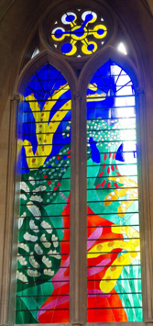  Westminster Abbey Stained Glass Windows  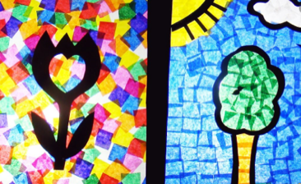  Model using the card and tissue paper to recreate the image of David Hockney’s stained glass window.
To shape and model materials for purpose | British Sculptor: Michelle Reader  Show children the PowerPoint (Twinkl Art: Let’s Sculpt KS1 Lesson Pack 2)  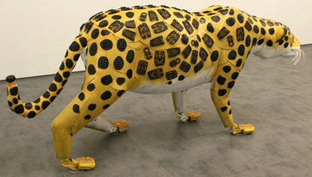  Who is Michelle Reader – what is she famous for? Which of her piece of artwork do you like? Why?  Explain that she uses junk materials to create figurative pieces, which means they look like real things. Can the children see what materials/objects she has used to create each of her pieces?  Explain that today we are going to create work in her style | 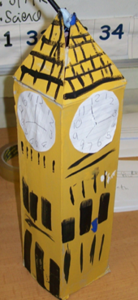  Junk Modelling – Architecture of the State  Show children the range of materials available to them. Explain that they are going to use these objects/materials, to create one of the famous buildings we have learnt about so far this half term. Which materials will be the most useful? Which will we need to shape, change or add things to? Why?  Children begin to build their models and paint add detail in the next session
To describe the work of significant artists | 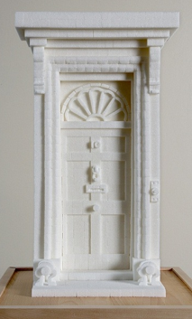  British Sculptor: Brendan Jamison  Show children the PowerPoint (Twinkl Art: Let’s Sculpt KS1 Lesson Pack 5)  Who is Brendan Jamison? What is he famous for? What materials does he use to create his work? What similarities does he have to Michelle Reader? What differences does he have? Which of his artworks do you like? Why? Can you identify the materials he has used in each of his artworks?  Show children his work on the Tate Modern and explain that this is a significant building in London. What did he use to build it? | Sugar Cube Sculpture  Children use the sugar cubes to build one of the buildings they have been learning about this half term.  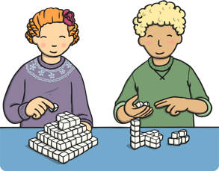  How will their work be different to the last session? Why?
To manipulate malleable materials in a variety of ways, including rolling, pinching and kneading. | 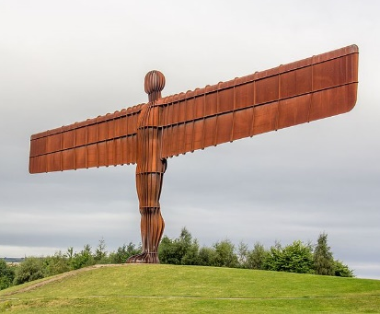  Explain to the children that in the next session we are going to continue our work on sculpture and we are going to create a sculpture of the Angel of the North out of clay. Show images of the Angel of the North so children can see the end goal. Show children the Powerpoint – see attached resources to introduce the use of clay.  What skills will we need to build this? How will we need to change the clay? How can we do this effectively? Model each of the clay skills Clay Skills-Twinkl – which of these will be most useful when creating our sculpture? Why? | 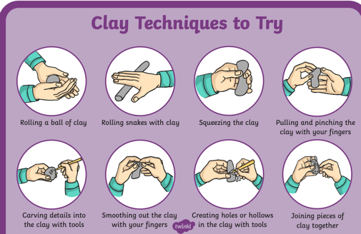  Clay Skills  Children move around a carousel of tables, trying the different skills with their clay. Which did they find easy? Which were more difficult?  Which skills do they think they will use in the next session?
To impress and apply simple decoration techniques, including painting  To use tools and equipment safely and in the correct way | Explain to the children that today they are going to be creating their Angel of the North sculptures using clay.  Which of the skills that we used in the last session will we need to use today. Model building the sculpture with the clay but ask the children to guide you in each step, using the skills mat used in the previous session. | 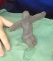  Angel of the North Sculpture  Children create their own sculptures out of clas.

Resources: https://learning.parliament.uk/en/resources/uk-parliaments-abc-primary-resource/

Invite a local MP in

